**COMPASS Porewater Sulfide Microplate Protocol**

**Written by:** Stephanie J. Wilson

**Date drafted:** 06/05/2022 **Updated:** 07/26/2023 by Alia Al-Haj

**Updated:** 09/22/2023 by Z. Read

**Overview:** Sulfide analysis on a sample or standard is completed by adding a sample to Cline’s Reagent and mixing. After 30 minutes, a blue color develops in all samples and standards. Samples with very low sulfide concentrations will initially appear pink, but fade to clear within 30 minutes.

**Objective:** To measure sulfide in synoptic site porewater samples collected during monthly or campaign style sampling efforts.

**Safety:** Wear gloves at all times, and wear full PPE (gloves, lab coat, and goggles) when using Cline’s Reagant.

**Reagents:**

5% Zinc Acetate: ZnAc in DI or MiliQ H2O (25 g in 500 mL DI)

* CAS #: 5970-45-6 (ZnAc)
* Link: <https://www.fishersci.com/shop/products/zinc-acetate-dihydrate-crystal-baker-analyzed-a-c-s-reagent-j-t-baker-2/02004587?searchHijack=true&searchTerm=zinc-acetate-dihydrate-crystal-baker-analyzed-a-c-s-reagent-j-t-baker-2&searchType=Rapid&matchedCatNo=02004587>

Cline’s Reagent: 2 g of N,N-dimethyl-p-phenelynediamine sulfate + 3g ferrice chloride (FeCl3 6H2O) in 500 mL cold 6N (50%) HCl.

* See data sheet on diamine before *handling (Handle diamine in fume hood)*
* This reagent is stored in the fridge (in brown glass container)
* Lasts up to 6/8 months
* CAS #: 536-47-0 (diamine), 10025-77-1 (FeCl3)
* Links: <https://www.fishersci.com/shop/products/n-n-dimethyl-p-phenylenediamine-sulfate-99-thermo-scientific/AC181430250> (diamine), <https://www.fishersci.com/shop/products/ferric-chloride-hexahydrate-acs-labchem/LC142901> (FeCl3)

2.5 mM ZnS; Sulfide Stock Standard: 0.300 g Na2S 9H2O in 500 mL 5% ZnAc

* After making this in a volumetric flask a white precipitate will form
* Take this out of the fridge, stir on stir plate, and let it come to room temperature before using to make standards
* Constantly stir this solution as you pipette what you need
* You will only need a small amount of standard, so you may make less than 500 mL
* Make new standard each time you measure sulfide samples (every month)
* Be careful not to let it clump
* CAS #: 1313-84-4 (Na2S), 5970-45-6 (ZnAc)
* Links: <https://www.fishersci.com/shop/products/sodium-sulfide-nonahydrate-98-acs-reagent-thermo-scientific/AC424420250> (Na2S)

Matrix Effect Artificial Seawater:

* 10ppt: 10g NaCl, 0.2g NaHCO3 in 1000mL DI H2O
* 20ppt: 20g NaCl, 0.2g NaHCO3 in 1000mL DI H2O

**Supplies:**

2x 500 mL Volumetric Flasks

Clean/ New Plastic 20mL Scintillation vials

96-well microplates

Pipettes & Tips (10mL, 1000uL, 100uL)

Vortex mixer

Stir bar & Mixing plate

Microplate Reader

**Laboratory preparation for sampling:**

1. Make 5% ZnAc (25g in 500mL)
2. Add 0.5mL 5% ZnAc to a clean 5mL Eppendorf tubes (acid washed and dry) (aka 500 uL)

You can adjust this volume based on your sulfide concentrations; if you have very high sulfide you can do 5 mL, if very low you may want to test lower amounts so that you do not further dilute the sample

**Field collection:**

1. Slowly draw up 6/8 mL of porewater from lysimeter or sipper through a 3-way stopcock into a syringe
2. Close stopcock
3. Tap the syringe to float air bubbles to the surface, and remove air bubbles from syringe
4. Remove syringe from stopcock and attach a 0.45 uM syringe filter with a needle on the end of the filter

Filter Link:

1. Discharge ~2 mL of sample through the filter and needle to rinse the filter and discharge any air in the filter/needle
2. Insert needle into sample vial under the ZnAc surface and slowly discharge 5 mL of sample directly into vial. If the volume is different than 5 mL record the volume if it differs for dilution correction later.
   1. Keep needle under ZnAc to avoid oxidation of the sulfide!
3. Put sample on ice until it can be placed in the refrigerator.

**Analysis Prep:**

1. Ensure we have ample supplies to do the analysis
   1. Check the supplies section
2. Plan your plate(s):
   1. Use the Microplate fill-in excel sheet (it is helpful to print these and have them with you when you are pipetting to keep your wells straight)
   2. Don’t forget to include standards on every plate, matrix effect checks, and some spikes and duplicates
   3. Place samples in order and then fill out microplate sheet
   4. Run a plate with only standards first to check the standard curve and see if you need to remake standards



Fig. 1. Screenshot of microplate fill-in excel file

**Laboratory analysis:**

1. Make stock standard and continuously stir it while preparing standard curve
2. Dilute standards

I make up my standards in 20mL scintillation vials then pipette from those

Add DI first, then pipette stock standard using 20-200 uL pipette. Use a new tip for each standard, and put the tip under the DI water in the scintillation vial when pipetting.

May need to add stock standard to a scint vial to be able to pipette it.

VORTEX the stock standard or keep it on the stir plate while pipetting.

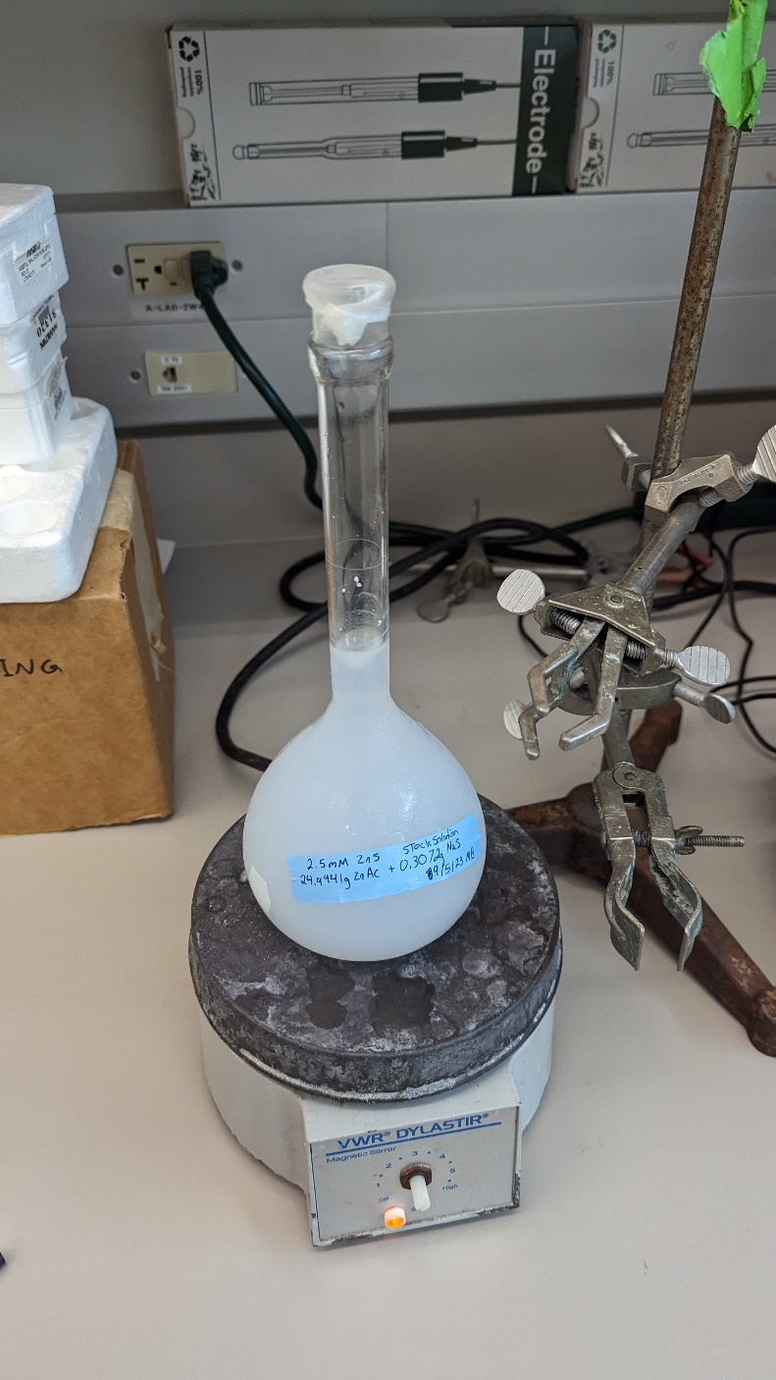

Sulfide stock standard on stir plate.

|  |  |  |  |
| --- | --- | --- | --- |
| Standard | [Sulfide] (uM) | H2O (mL) | Stock Standard (uL) |
| S0 | 0.0 | 10.0 | 0 |
| S1 | 5.0 | 9.98 | 20 |
| S2 | 12.5 | 9.95 | 50 |
| S3 | 25.0 | 9.90 | 100 |
| S4 | 50.0 | 9.80 | 200 |
| S5 | 100.0 | 9.60 | 400 |

Matrix Effect Standards:

|  |  |  |  |
| --- | --- | --- | --- |
| Standard | [Sulfide] (uM) | ASW (mL) | Stock Standard (uL) |
| S5: 10ppt | 100.0 | 9.60 | 400 |
| S5: 20ppt | 100.0 | 9.60 | 400 |

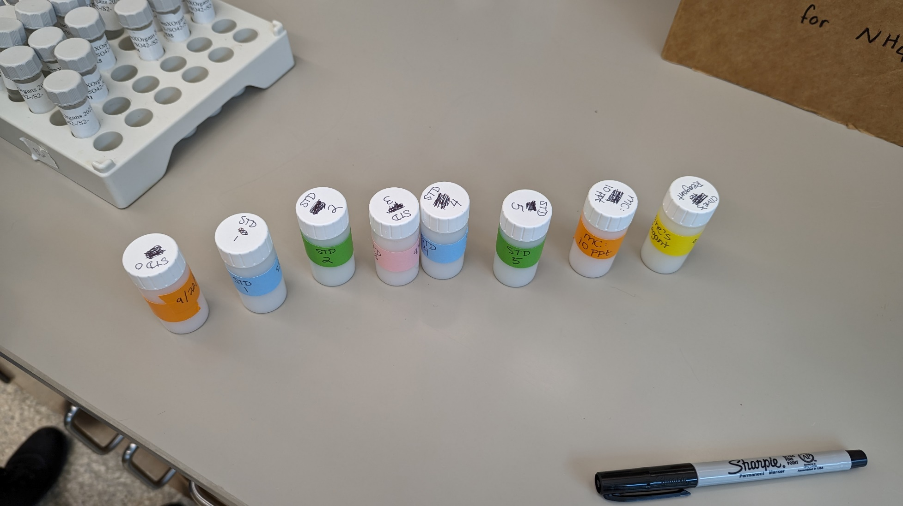

Set of standards and Cline’s Reagent in scintillation vials.

1. Pipette 250 uL of each standard into wells of a 96-well microplate
   1. Run standards in triplicate
   2. VORTEX standard vials before pipetting (~ 5 sec)
   3. Use 100 uL-1mL pipette
   4. Keep the pipette tip below the water level in each well to ensure all of the standard is dispensed
   5. Excess standards from pipetting go into the “sulfide waste” bin from the fume hood
   6. This sulfide waste is then dumped into the sulfide waste container next to the microplate reader in the fume hood room
2. Pipette 250 uL of each sample into wells (run in triplicate or duplicate)
   1. VORTEX sample vials before pipetting (~ 5 sec), you may need to tilt the vial to vortex the sample fully and shake the vial afterwards as well.
   2. Use 100 uL-1mL pipette for samples
   3. I have in some cases run in triplicate, but only spiked dups to have a background absorbance if the samples have some color to them (brownish, etc.)
   4. Run a few spiked samples per plate (add 10 uL of standard 5 (100 uM))
   5. If need to rerun with a dilution, dilute the sample so the value will be near the middle of the standard curve.
3. Add 20 uL of Cline’s Reagent to the standard and sample wells (ratio is 0.08 mL of dye to 1mL sample/standard)
   1. Add to a scintillation vial and VORTEX before pipetting
   2. Use 20-200 uL pipette
4. Allow color to develop for 30 mins
   1. Place microplate in a box (cooler or cardboard) to keep it in the dark during color development
   2. A blue color should develop quickly in the higher standards.
   3. Samples with low sulfide will turn pink then turn clear over time
5. Measure the absorbance in each well at 670 nm with a microplate reader.
   1. Read samples in SERC Terrestrial Ecology Lab
      1. Turn on spec
         1. Door will open
      2. Log into computer
      3. Open Gen 5 software
      4. “Create a new item” 🡪 “experiment”
      5. Select “default protocol”, press “ok”
      6. From plate menu at the top (bar), select “read”
         1. Little plate icon
      7. Select shake, set to slow shake for 10 seconds
      8. Add step “read” from the left
      9. Change wavelength to 670 nm
      10. Press “OK” then “OK”
      11. Press “read”
      12. Load the plate – match up A1 on holder to plate
      13. Click “OK”, door will close
      14. After plate is read, under “data” click “670: to see numbers
      15. Click excel button on top of file (next to name)
      16. Save excel file under COMPASS folder 🡪 Microplate Data 🡪 Sulfide
      17. Save the run file in the software as well
      18. Check the standard curve:
          1. Average the triplicates of each standard
          2. Plot standards in a scatterplot
          3. Check that the R squared is at least 0.98
          4. Need to use at least 2/3 of the triplicates for the standard curve
      19. Check whether samples need to be diluted:
          1. Find samples that are outside the range of the standard curve
          2. Find a dilution factor that will place the sample value at the middle of the standard curve (standard 3)
          3. Rerun samples with dilutions. Write the dilution factor on the plate layout sheet as well.
          4. Potential dilutions:
             1. 5x dilution: 50 uL sample, 200 uL DI water
             2. 25x dilution: 10 uL sample, 240 uL DI water
             3. 50x dilution: 5 uL sample, 245 uL DI water



Fig. 2. Example 96-well plate with color developed

1. Tap waste from plates into plastic cup and then place all waste in the sulfide waste container in the fume hood room, next to the microplate reader.

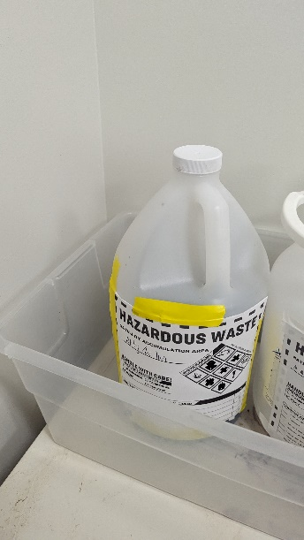

**Notes:** It is helpful to make dilutions prior to analyzing your samples so you have extra if you need it. If your sample looks darker than the highest standard you can dilute your sample. Alternatively, you may also increase the range of your standards. It takes ~1.5 hours to do one plate; Steph has done 4 plates in 4 hours.

This analysis can also be conducted in a cuvette or with a cuvette attached to a sipper (ask Steph Wilson for adjusted volumes if required)

**Literature:**

Cline, J. “Spectrophotometric Determination of Hydrogen Sulfide in Natural Waters.” (1969) Limnology & Oceanography. <https://doi.org/10.4319/lo.1969.14.3.0454>

Ehrhardt, M., Grasshoff, K., Kremling, K., and Almgren, T. “Methods of seawater analysis”